**Experiment no: -7**

Q1. Implement the producer consumer problem using pthreads and mutex operations.

Test Cases:

(a) A producer only produce if buffer is empty and consumer only consume if some contents is in the buffer.

(b) A producer produce an items in the buffer and consumer consumes the last produces item in the buffer.

(c) A producer produces on the last consumed index of the buffer .

Code : -

#include<stdio.h>

#include<pthread.h>

#include<stdlib.h>

#define N 10

int buffer[N];

int count = 0;

int in = 0;

int out = 0;

pthread_mutex_t mutex;

pthread_cond_t full;

pthread_cond_t empty;

void* producer(){

    int item;

    while(1){

        scanf("%d",&item);

        pthread_mutex_lock(&mutex);

        while(count == N){

            pthread_cond_wait(&empty,&mutex);

        }

        buffer[in]=item;

        in = (in + 1)%N;

        count++;

        printf("Producer produce item  : %d\n",item);

        pthread_cond_signal(&full);

        pthread_mutex_unlock(&mutex);

    }

}

void* consumer(){

    int item ;

    printf("\n\n");

    while(1){

        pthread_mutex_lock(&mutex);

        while(count==0){

            pthread_cond_wait(&full,&mutex);

        }

        item = buffer[out];

        out = (out +1 )%N;

        count--;

        printf("Consumer consume item :%d \n",item);

        pthread_cond_signal(&empty);

        pthread_mutex_unlock(&mutex);

    }

}

int main(){

    pthread_t t1, t2;

    pthread_create(&t1,NULL,producer,NULL);

    pthread_create(&t2,NULL,consumer,NULL);

    pthread_join(t1,NULL);

    pthread_join(t2,NULL);

}

Output : -

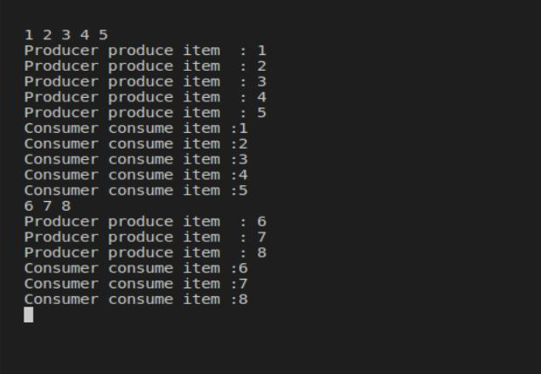

Q2. Implement the reader writer problem using semaphore and mutex operations to synchronize n readers active in reader section at a same time, and one writer active at a time.

Test Cases:

(a) If n readers are active no writer is allowed to write.

(b) If one writer is writing no other writer should be allowed to read or write on the shared variable

Code:-

#include <stdio.h>

#include <stdlib.h>

#include <pthread.h>

#include <semaphore.h>

#include <sys/types.h>

#define NUM_READERS 4

#define NUM_WRITERS 1

int shared_variable = 0;

int readers_count = 0;

sem_t mutex;

sem_t write_permission;

sem_t read_permission;

void *reader(void *arg) {

    int id = *(int *)arg;

    while (1) {

        sem_wait(&mutex);

        readers_count++;

        if (readers_count == 1) {

            sem_wait(&write_permission);

        }

        sem_post(&mutex);

        printf("Reader %d is reading the shared variable: %d\n", id, shared_variable);

        sem_wait(&mutex);

        readers_count--;

        if (readers_count == 0) {

            sem_post(&write_permission);

        }

        sem_post(&mutex);

        sleep(10);

    }

}

void *writer(void *arg) {

    int id = *(int *)arg;

    while (1) {

        sem_wait(&write_permission);

        printf("Writer %d is writing the shared variable\n", id);

        shared_variable++;

        sem_post(&write_permission);

        sleep(10);

    }

}

int main() {

    pthread_t readers[NUM_READERS], writers[NUM_WRITERS];

    int i, reader_ids[NUM_READERS], writer_ids[NUM_WRITERS];

    sem_init(&mutex, 0, 1);

    sem_init(&write_permission, 0, 1);

    sem_init(&read_permission, 0, NUM_READERS);

    for (i = 0; i < NUM_WRITERS; i++) {

        writer_ids[i] = i;

        pthread_create(&writers[i], NULL, writer, (void *)&writer_ids[i]);

    }

    for (i = 0; i < NUM_READERS; i++) {

        reader_ids[i] = i;

        pthread_create(&readers[i], NULL, reader, (void *)&reader_ids[i]);

    }

    for (i = 0; i < NUM_READERS; i++) {

        pthread_join(readers[i], NULL);

    }

    for (i = 0; i < NUM_WRITERS; i++) {

        pthread_join(writers[i], NULL);

    }

    sem_destroy(&mutex);

    sem_destroy(&write_permission);

    sem_destroy(&read_permission);

    return 0;

}

Output : -

